**For YOUR JOURNAL, this week, we are expecting the following.**

1. **Finish editing your movies in iMovie** ( no more than 30-40 minutes). You should clearly be able to describe how Daphnia and brine shrimp move. If you were fortunate enough to record brine shrimp mating, please also edit these videos. At the end of the course, I’ll be happy to avoid a few extra points for these movies. Throughout the course, every pair will come across a “fortunate” opportunity to record a movie with an especially cooperative specimen.

If you feel that your movies on Daphnia or brine shrimp fail to show locomotion you can substitute some movies on fresh water crustaceans or sowbugs. Please examine the doc label Substitutions for Daphnia and Brine shrimp.

**Your journal at the end of this activity should contain photographs of body segments (head, abdomen, etc.) and heart and gills for transparent specimens. There should be a movie on locomotion for Daphnia and brine shrimp, or substitute animals. I expect notes comparing in detail how the specimens you viewed locomote.**

2. We normally in this lab focus on how arthropods move.

The lab instructor will set up demo of beetle and millipede movement while you edit your movies**. In your journal you should describe how these organisms move in detail.**

a. Millipede ancestors were the first animals to make it on land. **What is the “foot” in these animals? How many legs move in tandem? Do they show tripod movement?**

b. How do the beetles use their legs to move forward. Do they show tripod movement? **What is the “distributed foot” that contacts the ground in walking? Is it the same “ distributed foot” used to navigate across barriers? Are spines or claws used in any way in locomotion? Please use your smart phone if they are available to record short movies of the animals or simply draw movement as best you can. Use the file labeled millipedes and desert beetles for reference.**

Again millipedes and desert beetles provide an excellent opportunity for a movie that can prove useful to the class. Keep them short and email them to me. I cannot use videos simply sent with text messages.

3. Every lab there will be arthropods for you to observe. You will be observing locomotion, feeding and other events. In this lab, please add Caprellids and horses shoe crabs to your list of arthropods to examine.

a. If *Caprellid* or skeleton shrimp survived please view locomotion in these animals. Despite pleas on bended knee, suppliers always pack these too tight. Colonies usually number in the hundreds and they often do not survive the trip here.  **They are truly spectacular animals so please spend a few minutes seeking out any survivors.**

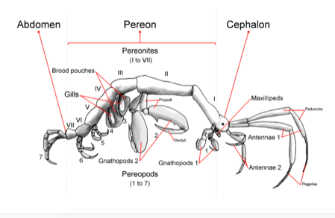

If you do not find any please look at the interesting animals shipped with them. There is usually a beautiful marine hydroid that I ask for in a later lab, but sometimes not available. Please obtain a photograph of these for your journal later. The hydroid colony is full of annelids, small crustaceans. Please take a photo of these that you will be able to use in the future. Begin to appreciate the vast number of organisms that make hydroid colonies their home.

b. Observe horseshoe crab feeding if possible and general external anatomy. We only have a few specimens of these. Therefore Bradley will try to get one of the specimens to feed for the class

4. Observe the organs and open circulation in grass shrimp.

Try to identify the different segments of the body, cephalothorax (carapace), and abdomen.

Try to locate some of the organs diagramed in the shrimp supplement. **List three organs or systems you were able to locate.**

**Locate the beating heart and take a video of it**. Try tracing open circulation, although you may not be able to film this. Use the film made by a student in your first lecture guide on arthropods as reference. Can you starting with the heart, and moving to the head or tail, trace the blood moving into an artery and that artery eventually disappearing. It is easier moving toward the tail with the main artery disappearing mid body.

**5**. Only if there is time, obtain photographs of mouthparts in Collembola to compare to mouthparts in termites, a true insect.

**Also try to obtain video to share with class of springtail behavior**. Another extra credit opportunity.